**What is Breadboard?**

A breadboard is a circuit board that is used to make temporary circuits. It is a platform for building and testing electronic circuit designs without soldering, and so is suitable for fast experimentation and prototyping. Electronic components such as sensors, indicators, other active and passive components can be plugged into a breadboard, and connected with “jumper wires” that also plug into the breadboard. Since these plugged connections are not permanent, components (and jumper wires) can be unplugged and reused in later circuits or designs. Breadboards are widely used in electrical

engineering. Engineers make use of them in order to test different products, where they are efficient and cost-effective. Once a design is finalized and well-tested, it can move from the breadboard into “production” where components are permanently soldered together (for greater reliability). Today, starting from tiny analog and digital circuits to big complicated CPUs, electronics are widely prototyped and tested on breadboards.

**Breadboard Basics:**

A breadboard is a simple plastic “board” featuring an arrangement of drilled holes each sized to fit either a small wire or a metal “lead” (or “pin”) that forms an electrical input or output to some sort of electronics component. Some of these holes are electrically connected to each other inside the breadboard, and the holes are arranged in a pattern that makes these connections obvious and predictable. Putting two wires or leads into two holes that are internally connected allows electricity to conduct between the two leads, just as if you’d physically attached them using solder. So implementing a circuit on a breadboard consists of plugging components into holes and then connecting them with plugged-in wires. No connections are permanent, so it is easy to correct mistakes, to try different layouts, and to tear down your circuit or design when done and reuse its components elsewhere.

The key to using a breadboard is to understand how its various holes are electrically connected. Orient your breadboard vertically as in the picture below left, and you will see two different patterns of holes. On the edges of the board are two vertical columns of connected holes; toward the center of the board are many horizontal rows of holes separated by a central valley running down the middle of the board. These holes are variously connected as shown in the figure below right.

|  |  |
| --- | --- |
|  |  |

The pair of vertical columns on each edge are connected all the way down the board. Any pin or wire put into any one of these four columns is connected to every other pin or wire in that column. Traditionally these are called *power rails* or the *power bus* and you will connect them to both to your + and – power supply, as well as to the + and – inputs to many components.

Each horizontal row of five holes on opposite sides of the central valley are also electrically connected. So any wire in one of those holes connects to other wires in the four other holes in that row (or “half row”). Holes are *not* connected across the central valley.

The following illustration demonstrates a simple breadboard circuit involving an LED and a resistor:

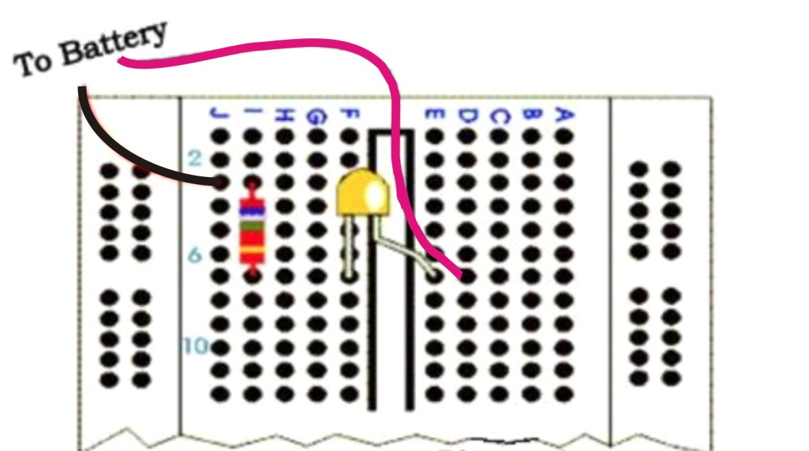

The LED has two legs (positive and negative) and is positioned straddling the central valley, so each leg is electrically separated from the other. The righthand (positive) LED leg is connected to the red battery wire because all five holes on the *righthand* side of row 7 are connected to each other. The lefthand (negative) LED leg is connected to one end of the resistor, because all five holes on the *lefthand* side of row 7 are also electrically connected. The opposite end of the resistor connects to the black battery wire in row 3. Because there is only one need for + power and one need for – power in the entire circuit, the power rails (vertical edge columns) are not used, and instead power is run from the battery directly into holes 3J and 7D. To trace the entire flow of current in the positive direction through the circuit, current flows from the battery

via the black lead to hole 3J,

then horizontally through the breadboard to hole 3I

the vertically through the resistor to hole 7I

then horizontally through the breadboard to hole 7F

then through the LED “over the central valley” to hole 7E

then horizontally through the breadboard to hole 7D

and then back to the battery through the red wire.

You’ll find it easy to work with breadboards, and many basic circuit designs include photographs or illustrations of breadboard layouts in which case it is simply a question of positioning the same elements (wires and electrical components) in your breadboard as depicted in the illustration. (This is vastly simpler than interpreting *circuit schematics*, which tell you how components are *logically* connected but not how they should be physically positioned.)

Be aware that breadboards come in different sizes and shapes, and some breadboards use a different pattern of electrical connection between holes. Instructions that come with your breadboard will note any differences from the standard layout shown above.